Vertical Machining Center（JN-FV1160）

Technical Document

By Jiangnan CNC Machine Co., Ltd.
By Jiangnan Technology (Songyang) Co., Ltd.

Party A: ： Party B: Jiangnan CNC Machine Tool Co., Ltd.
Date： Date：

1、Company Profile

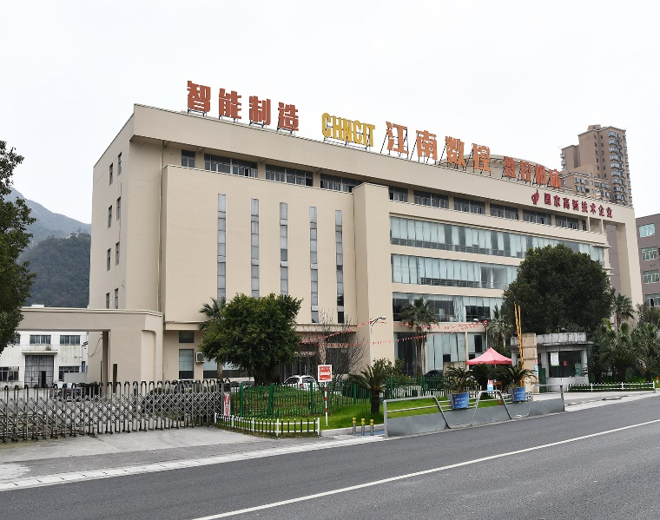
Jiangnan CNC Machine Tool Co., Ltd. is located in the beautiful coastal city of Wenzhou, China. It is a CNC machine manufacturing enterprise integrating research, design, manufacturing, and sales. The company was established in September 2006 and currently has a standardized plant covering an area of 85,000 square meters, with more than 180 excellent staff members. Among them, 90 employees have a college degree or above, accounting for 50% of the total staff; the company has 20 research and development personnel, accounting for 9% of the total workforce.
Adhering to the business philosophy of "technological innovation, win-win cooperation, integrity and efficiency, sincere service," and the quality policy of "quality first, customer foremost," the company provides customers with the most cost-effective products and comprehensive services, aiming to create the maximum value for customers. With advanced equipment including the world's most advanced large-scale CNC five-axis machining center and horizontal machining center, as well as contour grinding machines and high-precision Renishaw inspection equipment, the company strictly adheres to international standards. It has obtained ISO9001 certification and implements rigorous process inspections to ensure product quality.
- The company mainly manufactures vertical Machining Centers, horizontal Machining Centers, drVertical Machining Centers: JN-IV850, JN-NV856, JN-FV900, JN-NV1050, JN-IV1160, JN-NV1300, JN-NV1690, etc.
- Horizontal Machining Centers: JN-H50, JN-IH50, JN-H63, JN-IH63, JN-H800, JN-H1810, etc.
- Drilling and Tapping Machines: JN-T500, JN-T700, etc.
- CNC Lathes: JN-CH106, JN-CH108, JN-CH108M, JN-CH108MY, JN-CH208, JN-CH506MSY, etc.
- Gantry Series: JN-GL2013, JN-GL2015, JN-GL2518, JN-GL2720, JN-GL3023, JN-GL4023, JN-GL4027, JN-GL5030C, etc.
Our machine tools are popular in major provinces and cities in China, including Beijing, Shanghai, Chongqing, Tianjin, Hebei, Henan, Shanxi, Shandong, Jiangsu, Zhejiang, Guangdong, Anhui, Hubei, Fujian, and others, due to their excellent performance and first-class after-sales service. The company adopts a combination of direct sales and distributorship models and has cooperated with 100 distributors nationwide, covering major cities across the country.
Jiangnan CNC – A national brand, a national pride! We sincerely invite you to join with us to create a new era of high-tech machinery!
2.Introduction the Songyang Factory

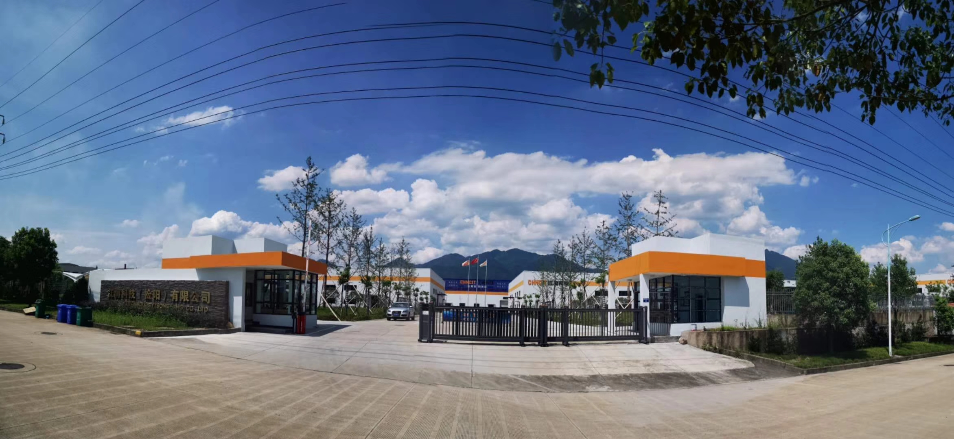

Jiangnan Technology (Songyang) Co., Ltd., a wholly-owned subsidiary of Jiangnan CNC Machine Tool Co., Ltd., was established in August 2017. Located in the beautiful scenic city of Songyang, Lishui, it covers an area of 107.69 acres with a total construction area of 29,693 square meters. The company has a registered capital of 50 million yuan, with fixed asset investment of 300 million yuan and working capital investment of 70 million yuan. It has introduced multiple sets of high-precision equipment such as the Japanese DAIWA CNC gantry five-axis machining center and horizontal machining centers.
Building on the development foundation of its parent company, Jiangnan Technology actively promotes brand building and product serialization strategies. Internally, it implements ERP systems and information construction, optimizing business processes, and enhancing the company's management level and core competitiveness. Facing the challenges of economic globalization, Jiangnan will continue to focus on the CNC machining center industry, adhere to market-oriented business philosophy, and persist in the direction of "internationalization, technologicalization, and industrialization." It will vigorously introduce advanced equipment, technology, and talents, integrate resources, leverage strengths, and strive to shape "Jiangnan" into a well-known enterprise in the international CNC machining center industry.

3.The technical parameters of the JN-FV1160
Item |  |  | Unit | Specification
Worktable | Table Size |  | mm | 1300*600
Worktable | Processing range |  | mm | 1100*600
Worktable | T-slot |  | mm | 100*18*5
Worktable | Table load |  | kg | 500
Travel | X/Y/Z travel |  | mm | 1100/600/550
Travel | Spindle nose to table surface |  | mm | 130-680
Travel | Spindle center to column surface |  | mm | 650
Spindle | Spindle taper |  |  | BBT40
Spindle | Spindle speed |  | rpm | 12000
Spindle | Spindle drive method |  |  | Direct drive
Spindle Motor | Spindle motor |  | kw | 11-15
Feed Rate | X/Y/Z cutting feed |  | mm/min | 1～10000
Feed Rate | X/Y/Z rapid feed |  | m/min | 48/48/48
Precision | Positioning accuracy |  | mm | 0.008
Precision | Repeat positioning accuracy |  | mm | 0.005
Automatic Tool Change System (Optional) | Tool magazine capacity |  | T | 24
Automatic Tool Change System (Optional) | Tool change method |  |  | Randomization
Automatic Tool Change System (Optional) | Max. tool diameter |  | mm | Φ78
Automatic Tool Change System (Optional) | Max. tool diameter (no adjacent) |  |  | Φ150
Automatic Tool Change System (Optional) | Max. tool length |  | mm | 250
Automatic Tool Change System (Optional) | Max. tool weight |  | kg | 7
Automatic Tool Change System (Optional) | Toolholder type |  |  | BBT40
Automatic Tool Change System (Optional) | Tool change time |  | s | 2.5(T-T)
Others |  | Air pressure demand | kg/cm2 | 5-7
 |  | Power requirement | Kva | 25
 |  | Machine weight | kg | 6000
 |  | Machine size | mm | 3150*2180*2450
The actual values for power supply, air pressure source, machine weight, and overall dimensions may vary due to different configurations and peripheral equipment.

4.Detailed supplier of main components
No. | Name | Manufacturer | Brand Origin | Remarks
1 | CNC System | MITSUBISHI | Japan | M80A
2 | Spindle Motor | MITSUBISHI | Japan | DG11/120
3 | X/Y/Z Axis | MITSUBISHI | Japan | HG204S HG204S HG303BS
4 | Ballscrew (X/Y/Z Axis) | PMI/ HIWIN | Taiwan | 40/40/40
5 | Linear Guideway (X/Y/Z Axis) | PMI/ HIWIN | Taiwan | 45/45/45
6 | Ballscrew Coupling | JANETECH | Taiwan
7 | Bearing | NACHI | Japan
8 | Electric Lubrication System | HERG | Joint Venture
9 | Cutting cylinder | HINAKA | Taiwan
10 | Spindle | POSA | Taiwan
11 | Tool Magazine | CHNCIT | China
12 | Cooling Pump | STAIRS | Taiwan
13 | Air Tank |  | China
14 | Pneumatic Components | SMC | Japan
15 | Transformer |  | LUHO
16 | Electrical Components | Schneider | France
17 | Telescopic Cover | CHNCIT | China
18 | Rear flush | CHNCIT | China
19 | Machine Peripheral Sheet Metal | CHNCIT | China

Note: If any supplier fails to supply, it will be replaced with a brand of equal quality without further notice.

5.Optional accessories list
No. | Name | Quantity/Unit | Note
1 | Oil cooler |  | TONGFEI/SAMENG
2 | Chip conveyor
3 | TSC
4 | Rotary table |  | 255 TJR
5
6
7
8

Quotation
Name | Quantity | Unit price(cny) | Amount(cny)
JN-FV1160 | 1 | 218500 | 218500
Oil cooler | 1 | 3000 | 3000
Chip conveyor | 1 | 8000 | 8000
TSC | 1 | 22100 | 22100
Rotary table | 1 | 35400 | 35400
Total mount |  |  | 287000
USD |  |  | 41000(USD)

6.Tools and manuals list
No. | Name | Quantity/Unit | Remarks
1 | Toolbox | 1Set
2 | Certificate of conformity | 1Copy
3 | Machine specification | 1Set
4 | Machine specification  System specification | 1Set
5 | Air gun | 1 Piece

7.Machine Mechanical Indicators
7.1、Machine Structure
Machine Structure The main structural components of the machine tool are made of high-tensile cast iron, optimized in design for high static rigidity. The spindle features a high-rigidity structure, high mechanical efficiency, suitable for high-precision heavy cutting machining. The spindle motor adopts AC servo technology, enabling stepless speed regulation in both forward and reverse directions. The three-axis ball screw and servo motor drive directly, with no transmission cumulative error, ensuring high repeatability and positioning accuracy. Automatic tool changing structure, quick and smooth tool changing operation. All machine components and various measurement units comply with international (ISO) standards.
7.2、Machine Protection
Machine Protection The machine protection device is safe, complete, and reliable. Machine noise: in compliance with national standards, 75dB. Electrical control cabinet sealed to prevent dust and water, IP65 rating.
7.3、Lubrication System
Lubrication System Adopts TZ electric lubrication device to quantitatively lubricate all sliding surfaces and ball screws. Adjustable lubrication time intervals and amounts to ensure 100% lubrication at all lubrication points. Machine displays an alarm in case of low oil level (oil shortage). Uses 68# guide rail lubricating oil. Lubrication tank capacity: 2 liters. Lubrication pump voltage: 220V, motor output power: 25W, maximum pressure: 2.5MPa, discharge flow rate: 110ml/min.
7.4、Pneumatic System
Pneumatic System Pneumatic system, pressure switches, solenoid valves, etc., realize pneumatic tool changing, pressure: 6-8KG/C㎡, flow rate: 220L/MIN, can clean the working area.
7.5、Electrical System
Electrical System The standard system has complete and reliable interlocking, safety protection, and fault self-diagnosis alarm functions. Equipped with RS232 standard communication interface, can use computer floppy disk for program storage.
（According to the requirements of users can provide the corresponding software）
Other systems can be provided according to user requirements.

